Jason Mathew

E Chanelling Report

1) What is the major problem being solved?

The major problem that is being solved here is able to book a doctor’s appointment at any hospital is register with the doctor they want to see for any illness they have.

2) What are the other problems being solved?

They also provide, Eco channelling, Home care, order Medicine, lab test etc….

3) Who are the users of the system?

The target market for this are usually patients, anyone who needs medicine but can’t leave the house(old people) even Homecare would apply to that same with Eco channelling. Not only old people but those who can’t leave the house for any other reason. People who need the Driving license medical

4) What benefits the each user gets

Customers benefit from less human interaction, more customer engagements, secure data transmission, east access and time saving.

5) What are the other alternative similar systems available and do a comparison

* Doc990
* Asirihealth
* Samutthana
* Lankahospitals
* Durdans
* Epid

6) Understand the process of channelling a doctor and briefly describe in words and in a graphical way.

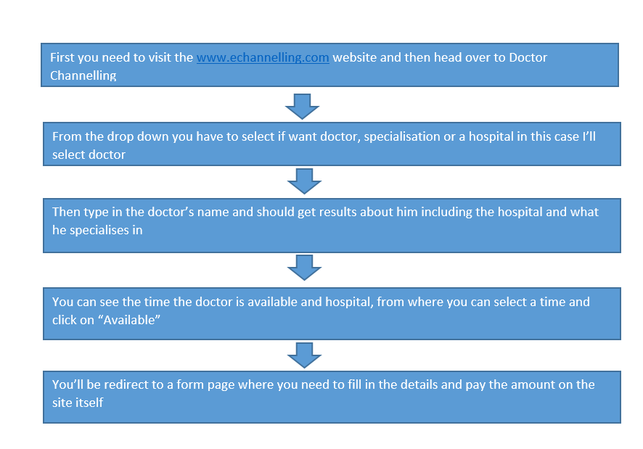 7) Describe the each user interface used in the process (workflow) of channelling the doctor (Hint: Use screen clipping feature in MS Word)

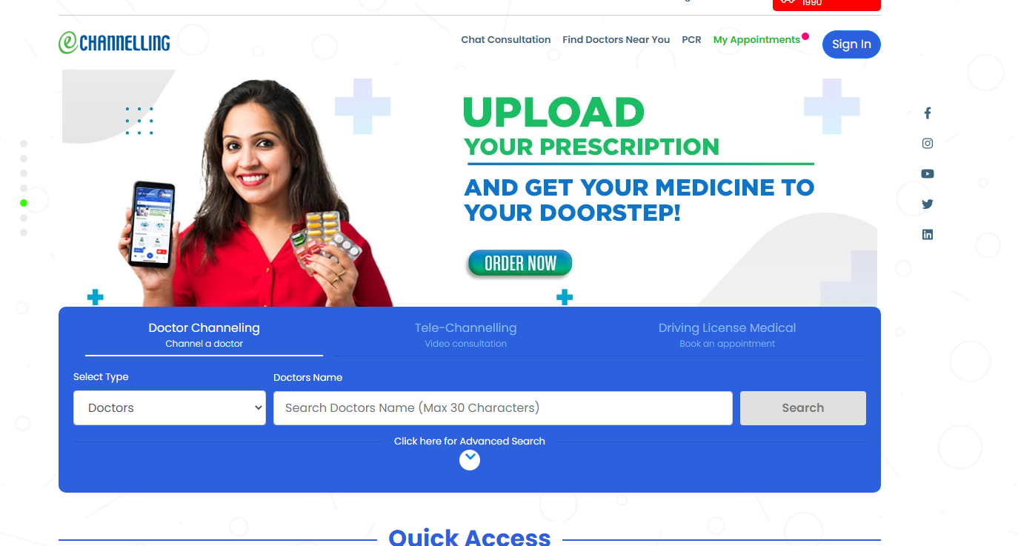

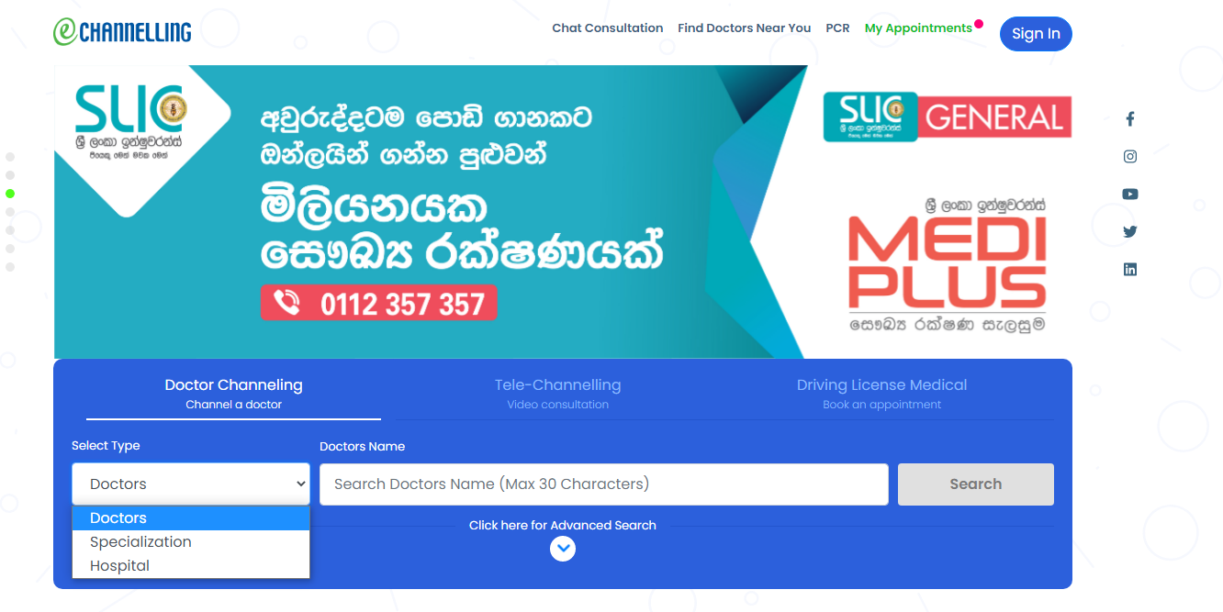

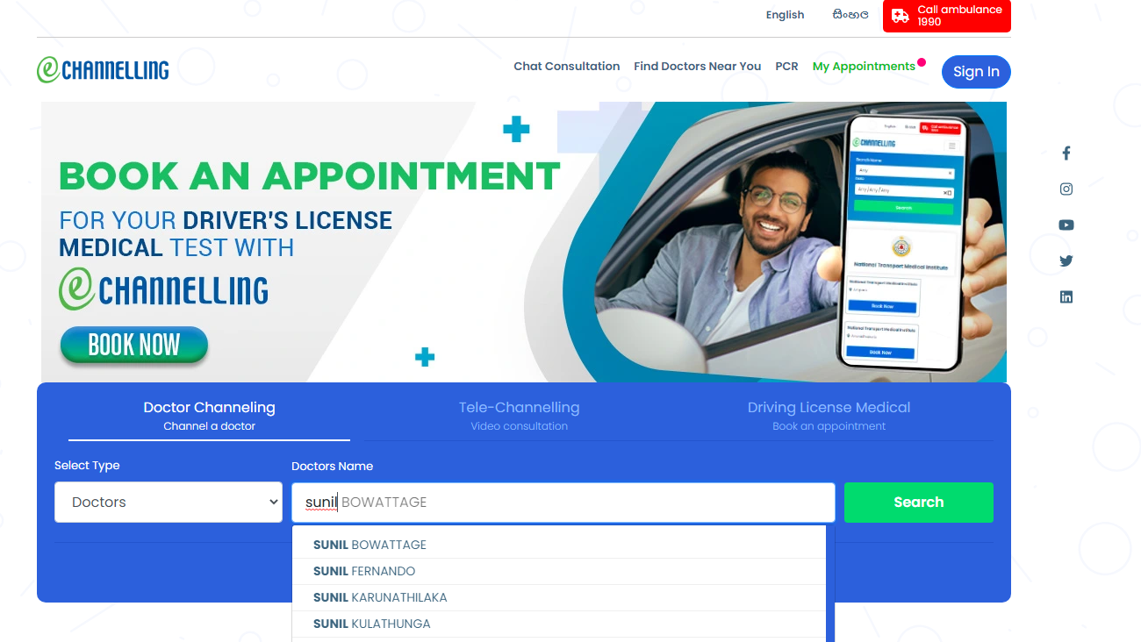

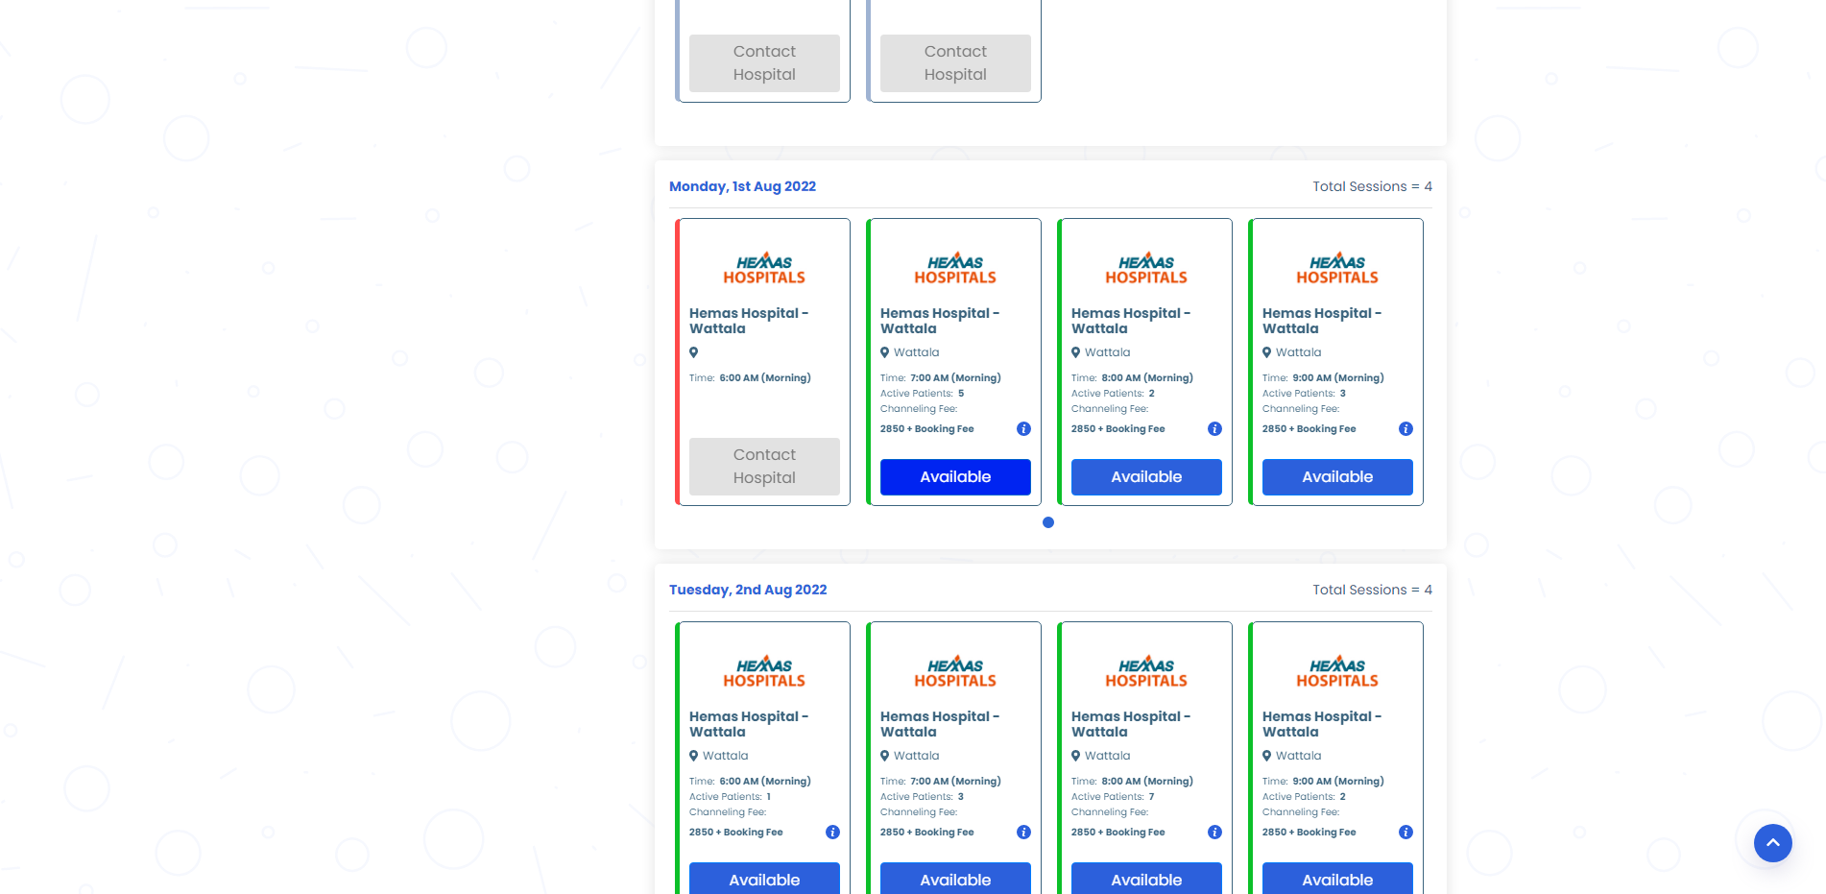

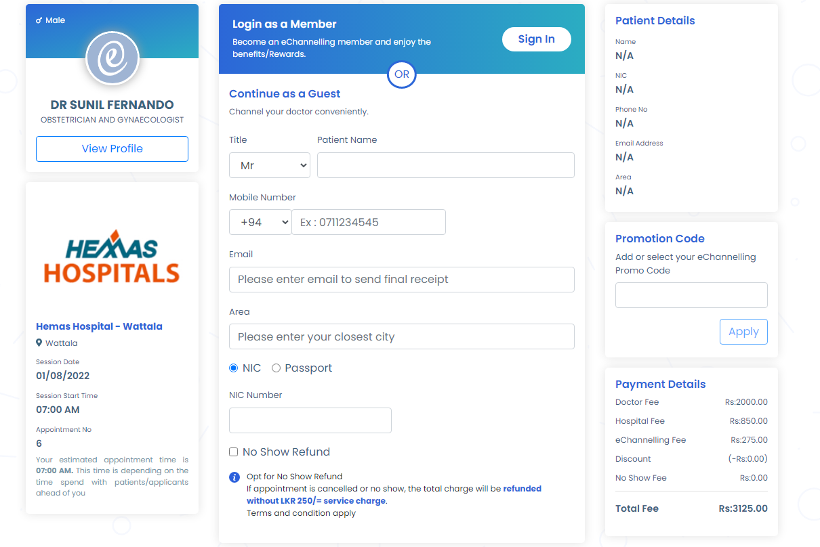

8) What is the type of software solution (desktop, client-server, web)

* Web

9) What should be the data stored in the database

* Doctor information (name, specialisation, hospital)
* Schedule
* Hospital information (doctors, closed-open)

10) Try to draw a technical diagram to illustrate the communication from browser network-server-database.

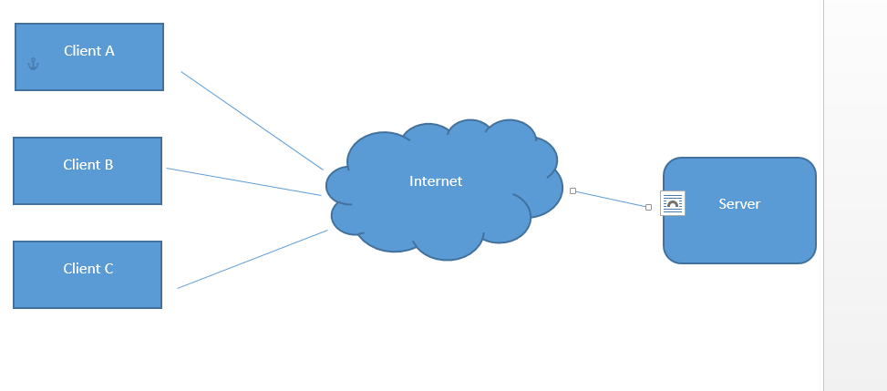

11) Do you think that the system has an administrative user? If so mention 3 tasks.

* Remove users
* Change website components
* Update the links and stuff

12) Considering total scenario, what are the processes and activities you cannot achieve through the system (that user should do manually)

* Enter area in the total page
* When select the doctor go to the next free time, instead of start of page
* If need medicine every 4 days, have to log in every 4 days

13) Suggest some ways of automating the activities that you mention in no. 12

* Using gps automatically fill that part
* Write an algorithm to show the next free time immediately
* Have a feature like a subscription to do the buying the delivering of medicine